遗传算法实验报告
学号201536551220 专业15网络工程 姓名贾中昊
Email:iacjacj@qq.com 手机：13719463640

一、实验背景

遗传算法是通过模拟生物进化在一个状态搜索空间里求解局部或者全局最优解状态的一种随机搜索算法的算法。交配概率、变异概率等参数会对算法的过程和结果产生影响。通过这个实验学习和不同研究参数所带来的影响。

实验内容

实验目标：研究交配概率和变异概率对遗传算法性能的影响

算法思路：
- 初始化：根据解向量的每个维度的取值范围随机生成100个解，作为第一代
- 评估：根据评估函数f(x1,x2) = 21.5 + x1 * sin(4 * pi * x1) + x2 * sin(20 * pi * x2)算出每个解的评估值，其中，-3 <= x1 <= 12.1，4.1 <= x2 <= 5.8
- 比较每个解的评估值，求出best评估值
- 判断是否满足代数大于500，否则执行循环
* 选择：求评估值总和，计算每个解的评估值占比，计算每个解的当前评估值占比累加和（其实就是轮盘赌的算法思路），根据轮盘赌的求解方法选出新的一代解数组，赋值给当前数组
* 交配：遍历每个解，每次随机生成一个概率，和交配概率比较决定符合交配条件的解，然后两两交换部分维度的值进行交配
* 变异：遍历每个解，每次随机生成一个概率，和变异概率比较决定当前解是否需要变异，如果满足就把解的每个维度随机生成新的值
* 评估
* 更新best值，当然也可以每次换掉最差的，如果best不用更新
- 运行代码10次，取结果的平均值
- 令交配概率取值0.1,0.2,0.3….,0.9，变异概率取值0.01,0.02，0.03，…0.09，不断重复上面的算法，比较结果，观察交配概率和变异概率对算法结果的影响
比较结果，观察交配概率和变异概率对算法结果的影响如图1、图2所示：
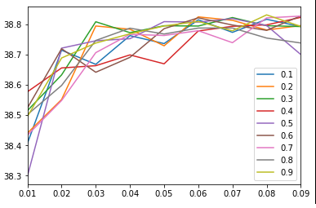
图1 不同交配概率和变异概率对算法结果的影响。横坐标是变异概率，纵坐标是最终最优结果，不同颜色表示不同交配概率。

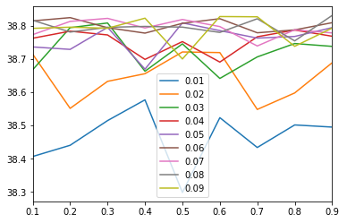
图2 不同交配概率和变异概率对算法结果的影响。横坐标是交配概率，纵坐标是最终最优结果，不同颜色表示不同变异概率。

三、实验方法

3.1、程序的修改
以下代码已上传至Github, 链接:
https://github.com/IACJ/python-TS/blob/master/AI_GA/GA.py

# -*- coding: utf-8 -*-
"""
Created on Sat Oct 21 17:55:45 2017

@author: IACJ
"""

import numpy as np
import sys
import math
import random
import time
import pandas as pd

class GT(object):
'GenoType，基因型'
def __init__(self,nVars,varBound):
'根据数值范围随机初始化各个基因'
self.nVars = nVars
self.varBound = varBound
self.fitness = 0
self.gene=np.zeros(self.nVars)
self.upper=[0] * self.nVars
self.lower=[0] * self.nVars
for i in range(self.nVars):
self.upper[i], self.lower[i] = self.varBound[i]
self.gene[i] = (self.upper[i]-self.lower[i])*random.random() +self.lower[i]
def copy(self):
'深复制函数'
copy = GT(self.nVars,self.varBound)
copy.fitness = self.fitness
copy.gene = self.gene.copy()
return copy

class GA(object):
'Genetic Algorithm, 遗传算法'
def __init__(self, popSize=100, maxGens=500,\
varBound=None,pXover=0.7,pMutation=0.07,report_detail=False):
if varBound==None:
print("varBound is required")
assert(varBound!=None)

self.popSize = popSize
self.maxGens = maxGens
self.nVars = len(varBound)
self.varBound = varBound
self.pXover = pXover
self.pMutation = pMutation
self.report_detail=report_detail
def describe(self):
print("popSize:",self.popSize)
print("maxGens:",self.maxGens)
print("nVars:",self.nVars)
print("report_detail:",self.report_detail)
def run(self):
'GA的运行入口'
self.generation=0
self.initialize()
self.evaluate()
self.keep_the_best()
while (self.generation<self.maxGens):
self.generation += 1
self.select()
self.crossover()
self.mutate()
self.report()
self.evaluate()
self.elitist()
return self.bestGT

def initialize(self):
'初始化'
self.population = [GT(self.nVars,varBound)] * self.popSize
self.bestGT = GT(self.nVars,varBound)
def evaluate(self):
'评估fitness'
for i in self.population:
i.fitness = 21.5 + \
i.gene[0]*math.sin(4*math.pi*i.gene[0]) + \
i.gene[1]*math.sin(20*math.pi*i.gene[1])
def keep_the_best(self):
'保存最优GT'
for i in self.population:
if i.fitness > self.bestGT.fitness:
self.bestGT = i.copy()
def select(self):
'选择算子--轮盘赌'
f_sum = 0
t_fitness = np.zeros(self.popSize) # true fitness
r_fitness = np.zeros(self.popSize) # relative fitness
c_fitness = np.zeros(self.popSize) # cumulative fitness
for i,j in enumerate(self.population):
t_fitness[i] = j.fitness
f_sum = t_fitness.sum()
r_fitness = t_fitness / f_sum
c_fitness = r_fitness.cumsum()
newPopulation = []
for i in range(self.popSize):
p = random.random()
for j in range(self.popSize):
if (p < c_fitness[j]) :
newPopulation.append(self.population[j].copy())
break
self.population = newPopulation

def crossover(self):
'交配算子'
mem = 0
first = 0
one = 0
for i in range(self.popSize):
p = random.random()
if p < self.pXover :
first += 1
if first % 2 ==0:
self.Xover(one,i)
else:
one = i
def Xover(self,GT1,GT2):
'基因交配'
if (self.nVars ==2):
point = 1
else:
point = random.randrange(1,self.nVars);
for i in range(point):
self.population[GT1].gene[i],self.population[GT2].gene[i] = \
self.population[GT2].gene[i],self.population[GT1].gene[i]
def mutate(self):
'基因变异'
for i in range(self.popSize):
for j in range(self.nVars):
p = random.random()
if p < self.pMutation:
self.population[i].gene[j] = \
(self.population[i].upper[j]-self.population[i].lower[j])*random.random() +self.population[i].lower[j]
def report(self):
'打印详情'
if (self.report_detail) :
print(self.generation,':',self.bestGT.fitness)
def elitist(self):
'每代保留最优，取代最差'
t_fitness = np.zeros(self.popSize) # true fitness
for i,j in enumerate(self.population):
t_fitness[i] = j.fitness
self.bestGT = self.population[t_fitness.argmax()].copy()
self.population[t_fitness.argmin()] = self.bestGT.copy()
if __name__ == '__main__':
print ('BEGIN')
varBound=[(-3.0,12.1),(4.1,5.8)]
btime = time.time()
result = np.zeros((9,9))
df = pd.DataFrame(result,index=np.arange(0.01,0.1,0.01),columns=np.arange(0.1,1.0,0.1))
for pMutation in np.arange(0.01,0.1,0.01):
for pXover in np.arange(0.1,1.0,0.1):
print(pMutation,pXover)
temp_sum = 0
for i in range(10):
myGA = GA(varBound=varBound,pXover=pXover,pMutation=pMutation)
bestGT = myGA.run()
temp_sum += bestGT.fitness
print(bestGT.fitness)
temp_sum /= 10
df.at[pMutation,pXover] = temp_sum
print ('pMutation',pMutation,'pXover',pXover,'bestGT.fitness',temp_sum)
df.plot()
df.T.plot()
df.to_csv('result2.csv')
etime = time.time()
print(etime - btime )
print ('END.')

3.2、算法流程图
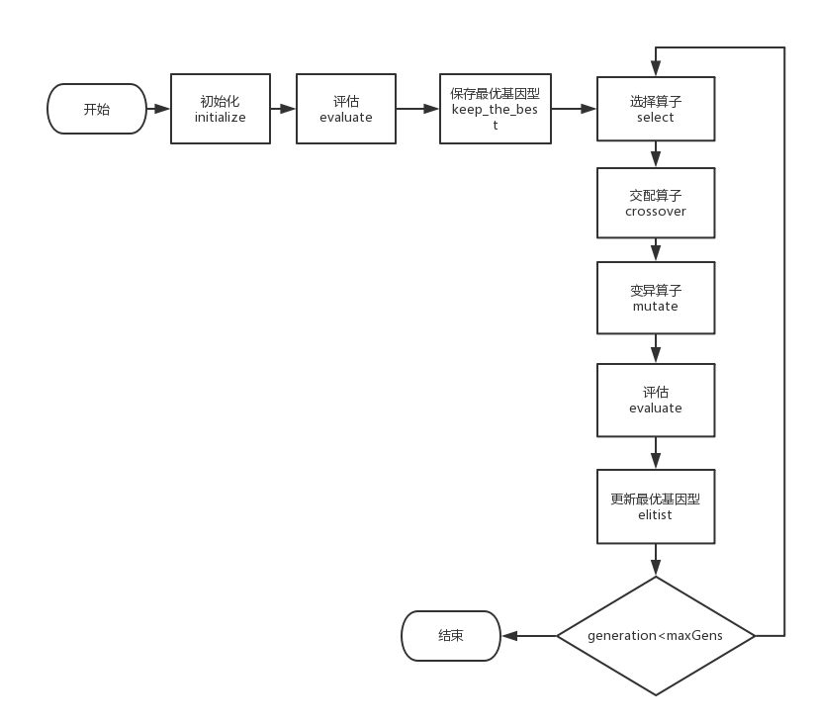

实验结果与讨论

* 实验结果：不同参数组合下的GA性能比较。
表1 不同参数组合下的GA性能比较
pc  pm | 0.1 | 0.2 | 0.3 | 0.4 | 0.5 | 0.6 | 0.7 | 0.8 | 0.9
0.01 | 38.40690445 | 38.44055988 | 38.51469004 | 38.57695159 | 38.29886552 | 38.52348718 | 38.43392668 | 38.50164143 | 38.49517209
0.02 | 38.71400472 | 38.55140247 | 38.6324829 | 38.65547843 | 38.72074736 | 38.71888352 | 38.54818728 | 38.59769483 | 38.68828158
0.03 | 38.6673714 | 38.79373937 | 38.80772389 | 38.66288997 | 38.74506959 | 38.64125985 | 38.70588079 | 38.74606092 | 38.73752218
0.04 | 38.76198109 | 38.78315755 | 38.77185839 | 38.69842883 | 38.75182151 | 38.69038026 | 38.76635459 | 38.78655111 | 38.76796945
0.05 | 38.73578844 | 38.72844887 | 38.79452481 | 38.6691054 | 38.80808562 | 38.78484806 | 38.7623816 | 38.76731058 | 38.79380119
0.06 | 38.81406866 | 38.8237942 | 38.7936063 | 38.77731891 | 38.80666652 | 38.82066624 | 38.7783232 | 38.78693798 | 38.80865919
0.07 | 38.77278976 | 38.8125267 | 38.82156204 | 38.79275701 | 38.81825832 | 38.79692879 | 38.7387281 | 38.78726074 | 38.7778613
0.08 | 38.81588682 | 38.78050619 | 38.79474576 | 38.79743221 | 38.7952843 | 38.7794605 | 38.82045477 | 38.75402247 | 38.83037395
0.09 | 38.79167107 | 38.79515693 | 38.79189129 | 38.82218071 | 38.69969898 | 38.82708407 | 38.82635994 | 38.73772375 | 38.79244822
比较结果，观察交配概率和变异概率对算法结果的影响如图1、图2所示：
图1 不同交配概率和变异概率对算法结果的影响。横坐标是变异概率，纵坐标是最终最优结果，不同颜色表示不同交配概率。

图2 不同交配概率和变异概率对算法结果的影响。横坐标是交配概率，纵坐标是最终最优结果，不同颜色表示不同变异概率。

实验总结
通过这次实验，我对GA算法的理解有了进一步的加深，发现用GA来搜索状态空间的局部甚至是全局最优解的效率是很高的，并进一步了解了python的用法。该代码已上传到Github：
https://github.com/IACJ/python-TS/blob/master/AI_GA/GA.py
感觉受益匪浅！

